**CSA1518-CLOUD COMPUTING**

T. Ashwath

192011375

**EXPT 13**: Demonstrate Infrastructure as a Service (IaaS) by creating a Virtual Machine using a Public Cloud Service Provider (Azure), configure with required memory and CPU.

IMPLEMENTATION:

STEP 1:SELECT VIRTUAL MACHINE

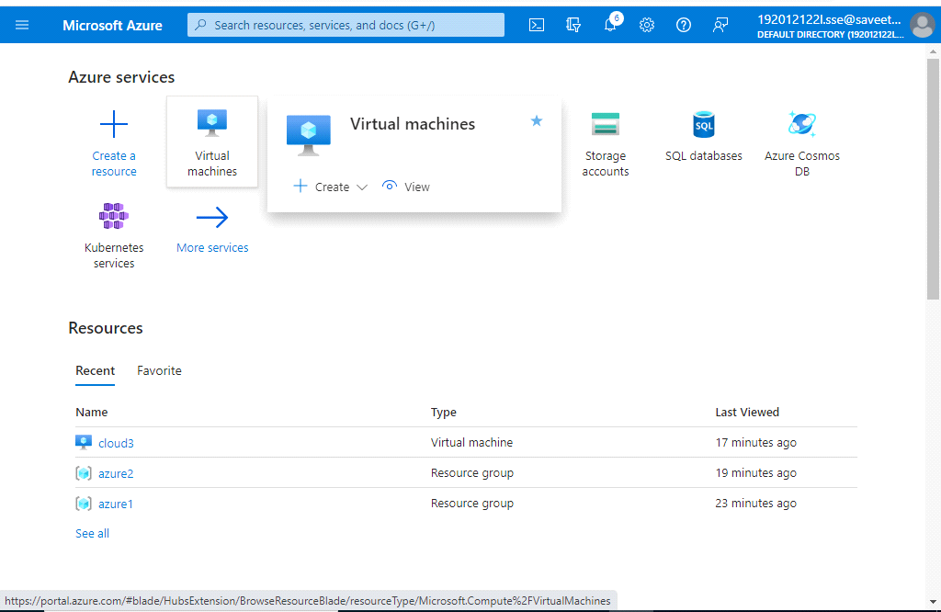

STEP 2:CLICK ON CREATE

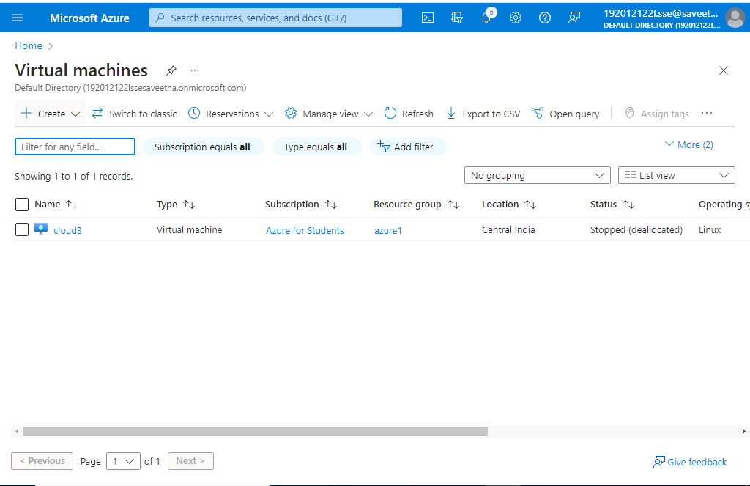

STEP 3:SELECT AZURE VIRTUAL MACHINE

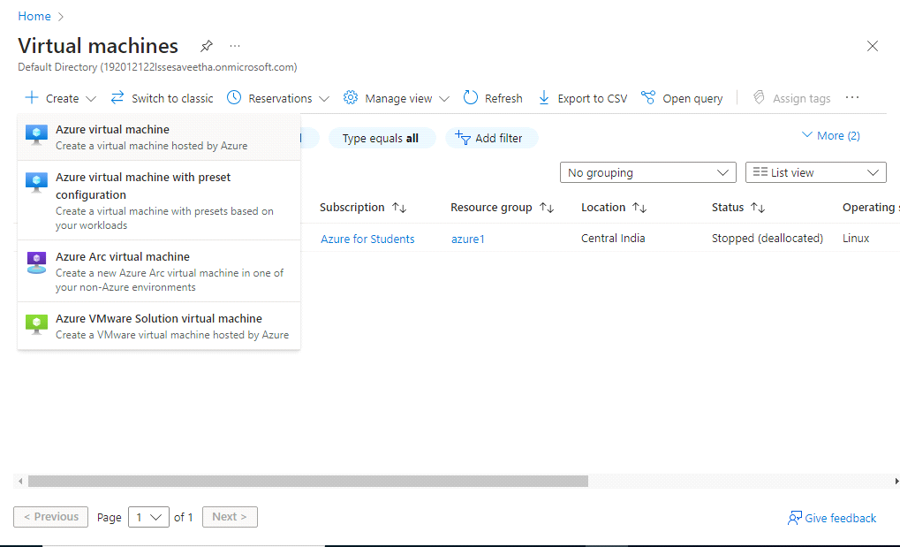

STEP 4:FILL THE DETAILS IN MANDATORY COLUMNS

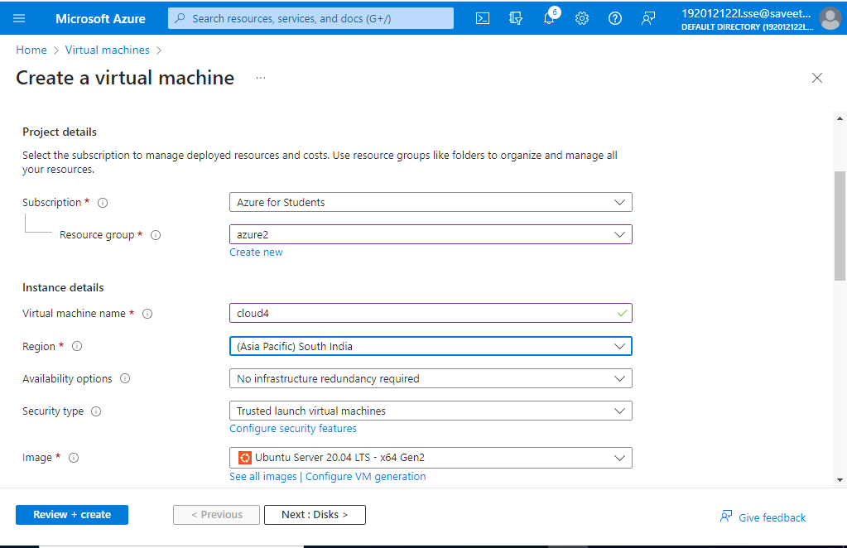

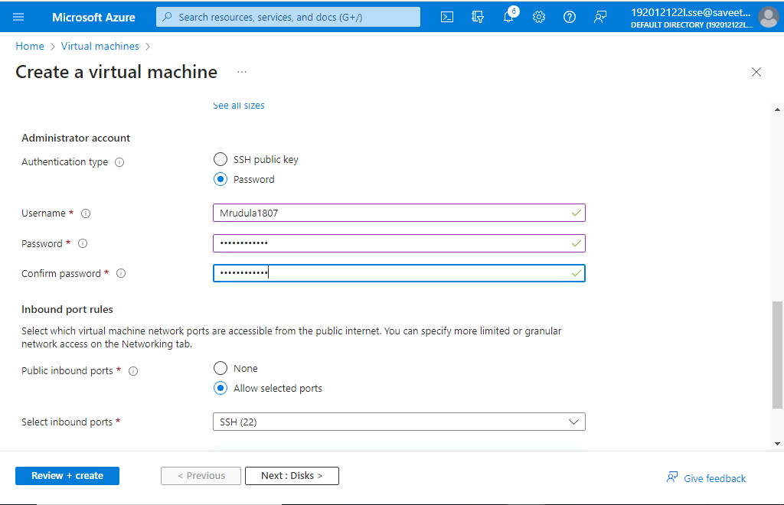

STEP 5:CLICK ON NETWORKING

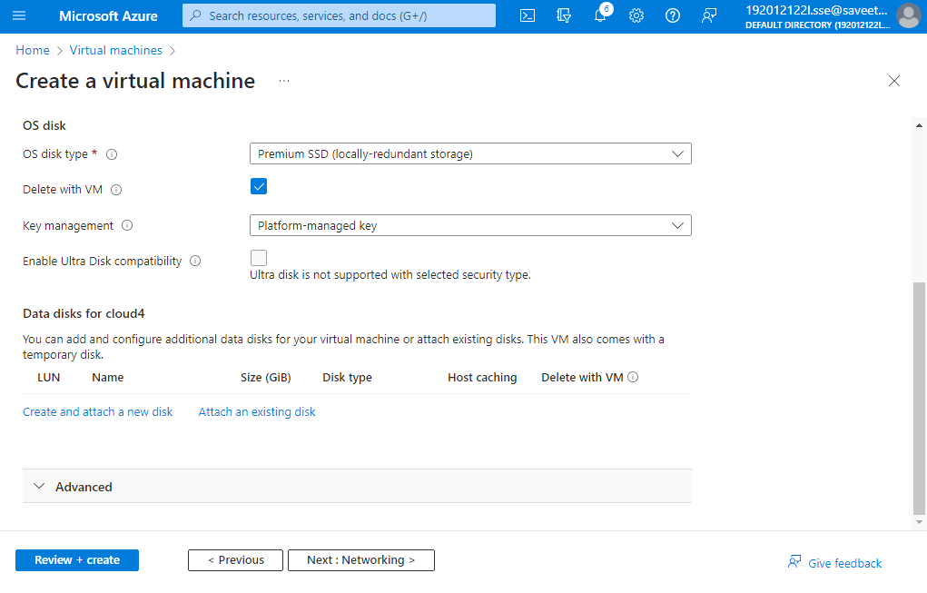

CREATE DISK

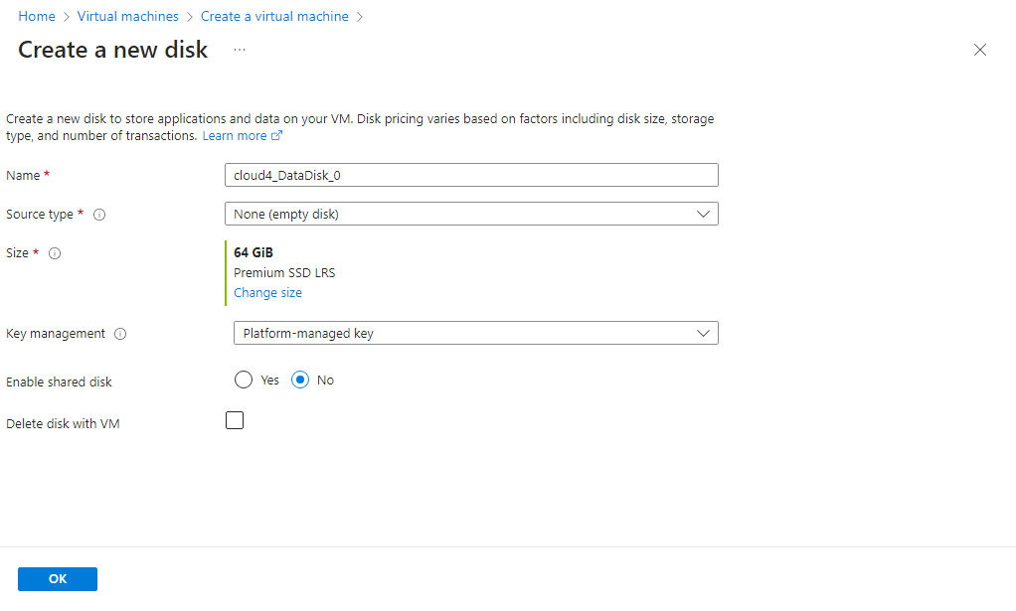

STEP 6:CLICK NEXT: MANAGEMENT

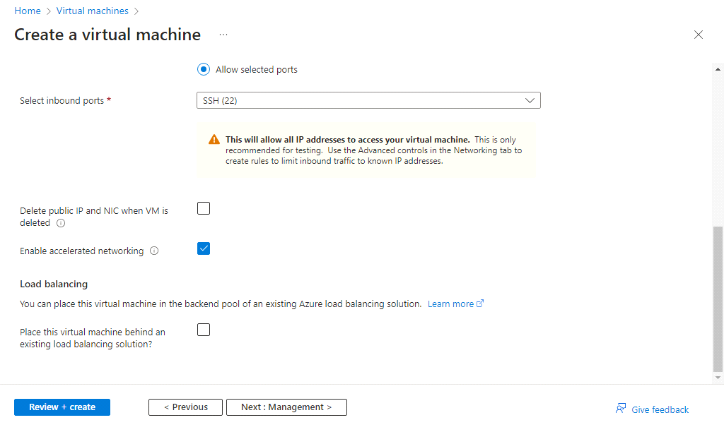

STEP 7:CLICK NEXT:MONITORING

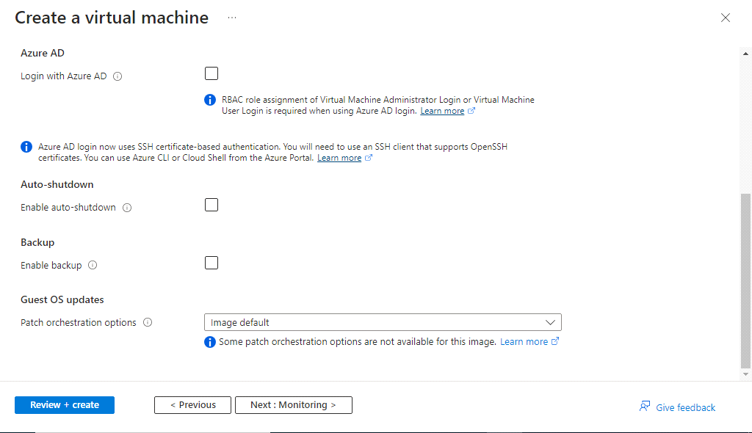

CLICK ON ADVANCED

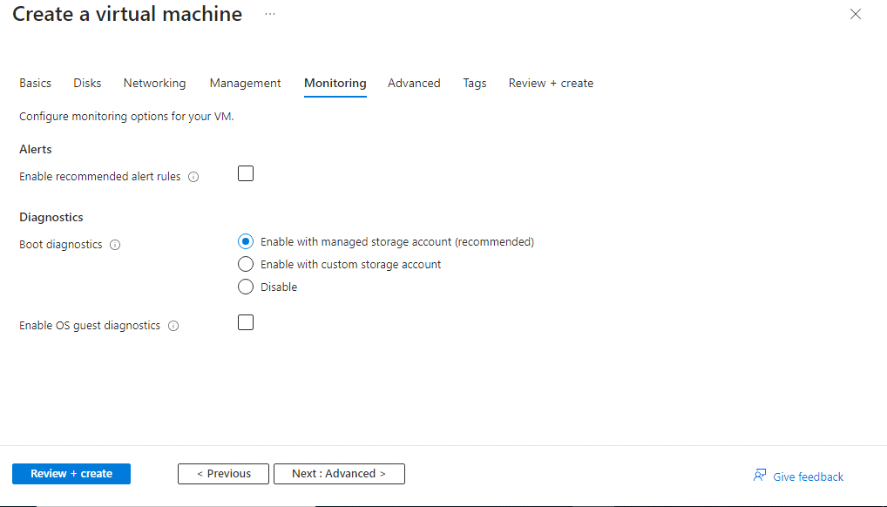

CLICK ON TAGS

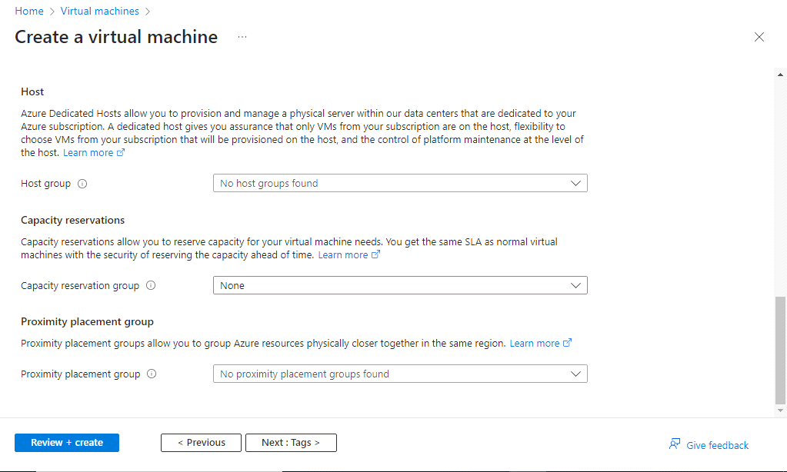

STEP 8:ASSIGN NAME AND VALUE

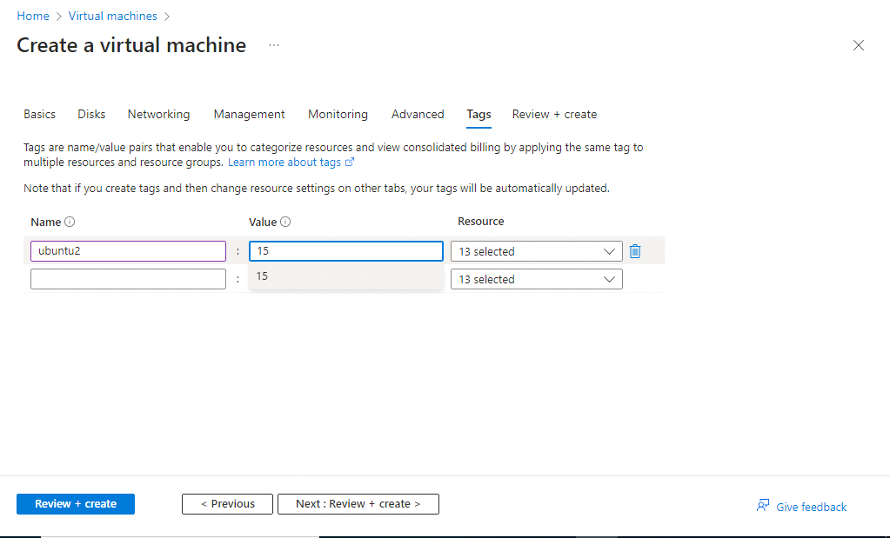

STEP 9:VALIDATION IS PASSED.CLICK ON CREATE

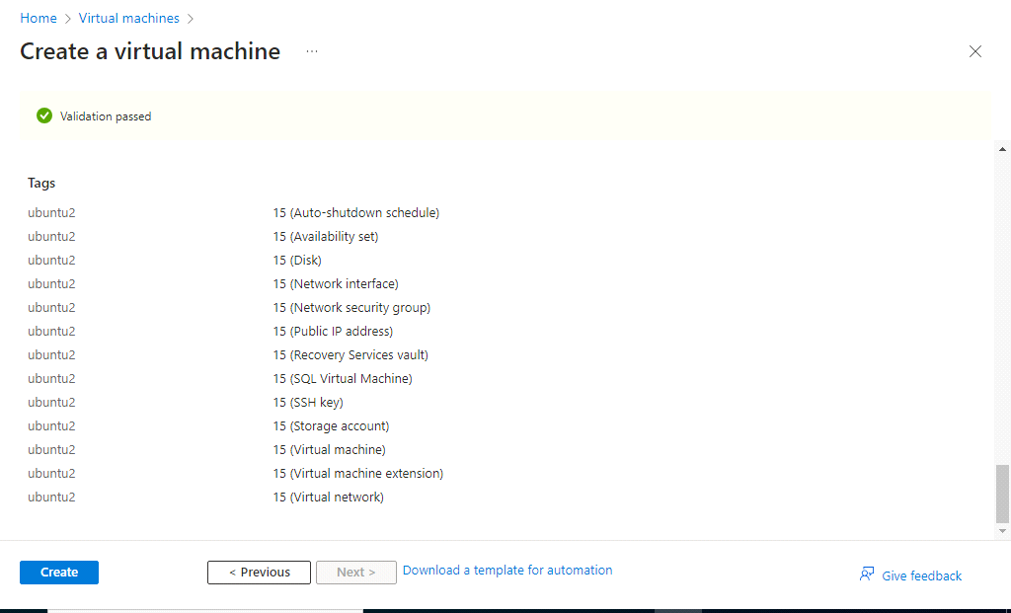

STEP 10:DEPLOYMENT IS COMPLETED

OUTPUT

